Bootstrap - Assignment

Session 2

Duration (20 Hours)

1) Create a Dashboard like the link in following in Bootstrap 4

[Annex - Responsive Bootstrap 4 Admin Dashboard](http://mannatthemes.com/annex/vertical/index.html)

<http://mannatthemes.com/annex/vertical/index.html>

1. Design using Bootstrap 4
2. Create a sidebar and the box UI components.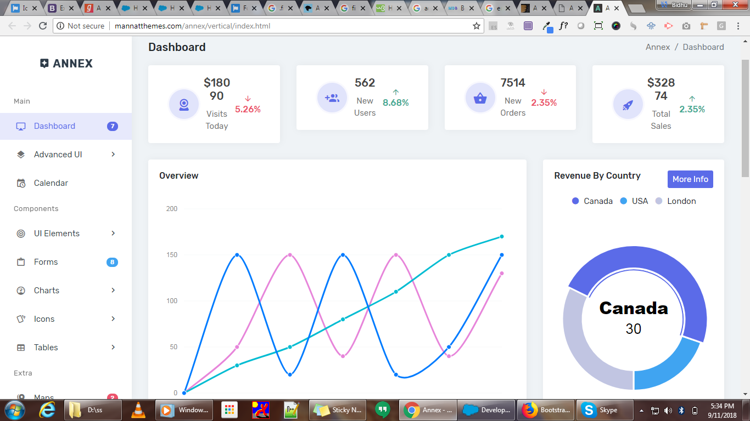
3. Use Static Icons only, no need to add Animations.